The 2018 Parklife Heavitree Grass Mixed 4’s Tournament, will take place on Saturday 30th June 2018 (10:00 - 16:00) at Heavitree Pleasure Grounds, Exeter. This event is a Park Volleyball 4x4 mixed event, teams can be all male, all female or any combination.
The cost per team is £30, with an early bird special of £24 for entries received before 30th May. Payment can be made online, please contact Rachel for more details or by cheque made payable to Parklife Heavitree
Entries are encouraged before 30th May to take advantage of the special rate and will close on 23rd June 2018.
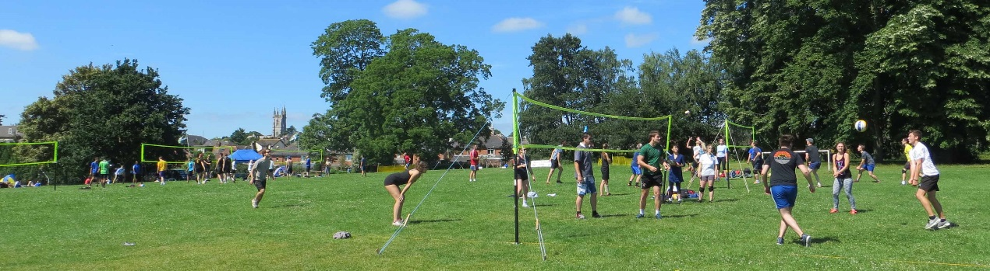
- - - - - - - - - - - - - - - - - - - - - - - - - - - - - - - - - - - -- - - - - - - - - - - - - - - - - - - -
Please print and send this part of the entry form (one per team) to: Rachel Swindell, Willowdene, Black Horse Lane, Blackhorse, Exeter, Devon, EX5 2AR.

I would like to enter the following team into the 2018 Parklife Heavitree 4’s Tournament on the 30th June 2018.

Team Name:

Preferred Division:

Playing Standard (National, Regional, Local, Beginners):

Name and Tel. of team contact:

E-Mail:

Number of Players in Team:

Payment (Online, cheque, cash):
Signed: Date:

